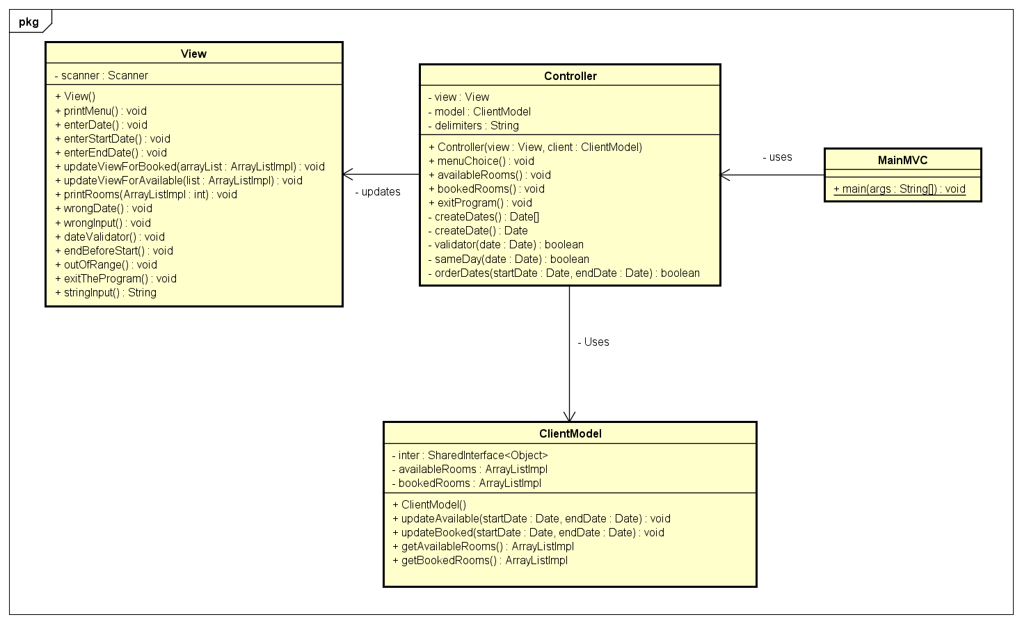**Model-View Controller**

The Model-View-Controller Pattern is used to separate the application's concerns. In our case the View is the output representation of information on the console, it generates new output to the user based on changes in the model. The Model directly manages the data, logic and rules of the system, it stores data that is retrieved according to commands from the controller and displayed in the view. A controller sends commands to the model to update information and it sends commands to the view to change the view's presentation of the data.